Project Design Phase-II
Data Flow Diagram & User Stories

Date | 27 September 2026
Team ID | SWTID-2026-4039
Project Name | AI WeatherWise
Maximum Marks | 4 Marks

Data Flow Diagrams:
A Data Flow Diagram (DFD) is a visual representation of the information flows within the AI WeatherWise system. It shows how weather-related data enters the system, how the system processes the data using AI-based analysis, and how weather forecasts, alerts, and recommendations are delivered to the user.
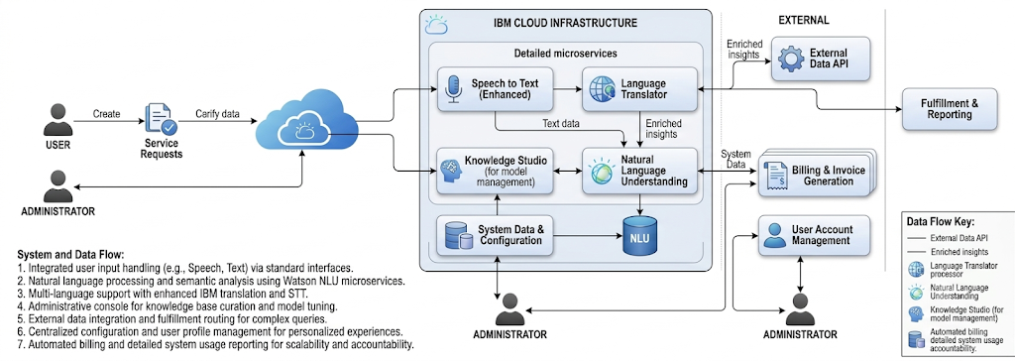

User Stories
Use the below template to list all the user stories for the AI WeatherWise product.
User Type | Functional Requirement (Epic) | User Story Number | User Story / Task | Acceptance criteria | Priority | Release
Customer (Web/Mobile user) | Registration | USN-1 | As a user, I can register for the AI WeatherWise application using my email and password. | I can create an account and access the application. | High | Sprint-1
Customer (Web/Mobile user) | Login | USN-2 | As a user, I can log into the application using my registered email and password. | I can successfully access my dashboard after valid login. | High | Sprint-1
Customer (Web/Mobile user) | Location | USN-3 | As a user, I can enter or select my location to view weather information. | Weather information for the selected location is displayed. | High | Sprint-1
Customer (Web/Mobile user) | Current Weather | USN-4 | As a user, I can view the current temperature, humidity, wind and weather condition. | Current weather details are displayed clearly. | High | Sprint-1
Customer (Web/Mobile user) | Forecast | USN-5 | As a user, I can view upcoming weather forecasts for my selected location. | Forecast information is displayed for upcoming days. | High | Sprint-2
Customer (Web/Mobile user) | AI Prediction | USN-6 | As a user, I can receive AI-based weather predictions and pattern analysis. | The system provides an AI-generated prediction based on available weather data. | High | Sprint-2
Customer (Web/Mobile user) | Weather Alerts | USN-7 | As a user, I can receive alerts for severe weather conditions such as heavy rain or storms. | A relevant alert is displayed when a severe condition is detected. | High | Sprint-2
Customer (Web/Mobile user) | Recommendations | USN-8 | As a user, I can receive AI-based recommendations based on the weather condition. | The system displays useful recommendations related to the forecast. | Medium | Sprint-3
Customer (Web/Mobile user) | Search Location | USN-9 | As a user, I can search for weather information for different locations. | Weather details for the searched location are displayed. | Medium | Sprint-3
Administrator | Weather Data Management | USN-10 | As an administrator, I can monitor weather data received by the system. | The administrator can view and monitor available weather data. | Medium | Sprint-4
Administrator | User Management | USN-11 | As an administrator, I can manage registered users. | The administrator can view and manage user accounts. | Low | Sprint-4

